1. Add new product into the system
2. Steps:

|  |  |
| --- | --- |
| Actor | System |
| 1. Choose command “Add Product”   Main Screen: | 1. Display “Add Product” screen:   Add Product Screen: |
| 1. Input data then click “Add” button   “Add Product” screen with data: | 1. Display “Add Product Confirmation” screen above “Add Product” screen:   “Add Product Confirmation” screen: |
| 1. Click on “OK” button | 1. Display “Main” Screen |

1. Add quantity and change price of product
2. Steps:

|  |  |
| --- | --- |
| Actor | System |
| 1. Choose command “Update Product Information”   Main Screen: | 1. Display “Update Product Information” screen:   Update Product Information Screen: |
| 1. Input ID of product then click “Load Product” button   “Update Product Information” screen with ID: | 1. Display “Update Product Information” screen with loaded data   “Update Product Information” screen with loaded data: |
| 1. Input new quantity and updated price. Click “Save Product” button   “Update Product Information” screen with new data: | 1. Display “Save Product” confirmation screen   “Save Product” confirmation screen: |
| 1. Click on “OK” button | 1. Display “Main” Screen |

1. Add new customer into the system
2. Actor: Customer
3. Steps:

|  |  |
| --- | --- |
| Actor | System |
| 1. Choose command “Add Customer”   Main Screen: | 1. Display “Add Customer” screen:   Add Customer Screen: |
| 1. Input data then click “Add” button   “Add Customer” screen with data: | 1. Display “Add Customer Confirmation” screen above “Add Customer” screen:   “Add Customer Confirmation” screen: |
| 1. Click on “OK” button | 1. Display “Main” Screen |

1. Change address of customer
2. Actor: Customer
3. Steps:

|  |  |
| --- | --- |
| Actor | System |
| 1. Choose command “Add Customer”   Main Screen: | 1. Display “Add Customer” screen:   Add Customer Screen: |
| 1. Input ID of customer then click “Load Customer” button   “Update Customer Information” screen with ID: | 1. Display “Update Customer Information” screen with loaded data   “Update Customer Information” screen with loaded data: |
| 1. Input new address. Click “Save Customer” button   “Update Customer Information” screen with new data: | 1. Display “Save Customer” confirmation screen   “Save Customer” confirmation screen: |
| 1. Click on “OK” button | 1. Display “Main” Screen |

1. Record purchase from customer into the system
2. Actor: Customer
3. Steps:

|  |  |
| --- | --- |
| Actor | System |
| 1. Choose command “Add Purchase”   Main Screen: | 1. Display “Add Purchase” screen:   Add Purchase Screen: |
| 1. Input data then click “Add” button   “Add Purchase” screen with data: | 1. Display “Add Purchase Confirmation” screen above “Add Purchase” screen:   “Add Purchase Confirmation” screen: |
| 1. Click on “OK” button | 1. Hide “Purchase Confirmation” and Display “Receipt” screen:   “Receipt” screen: |
| 1. Click on “OK” button | 1. Display “Main” Screen |

1. Change amount of product purchased
2. Actor: Customer
3. Steps:

|  |  |  |
| --- | --- | --- |
| Actor | | System |
| 1. Choose command “Update Purchase Information”   Main Screen: | | 1. Display “Update Purchase Information” screen:   Add Purchase Screen: |
| 1. Input ID of purchase then click “Load Purchase” button   “Update Purchase Information” screen with ID: | 1. Display “Update Customer Information” screen with loaded data   “Update Purchase Information” screen with loaded data: | |
| 1. Input new quantity. Click “Save Purchase” button   “Update Purchase Information” screen with new data: | 1. Display “Save Purchase” confirmation screen   “Save Purchase” confirmation screen: | |
| 1. Click on “OK” button | | 1. Hide “Purchase Confirmation” and Display “Receipt” screen:   “Receipt” screen: |
| 1. Click on “OK” button | | 1. Display “Main” Screen |

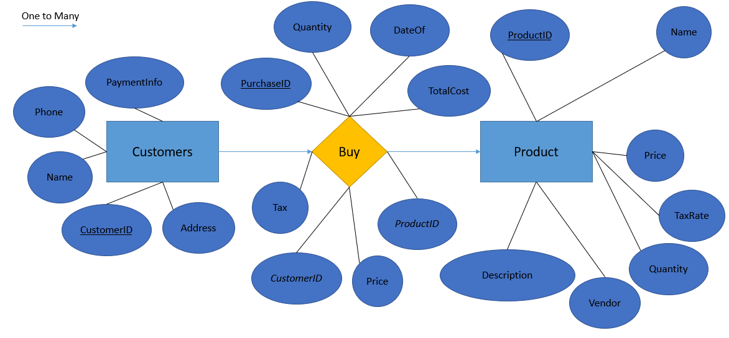

Entity:

Products(**ProductID**, Name, Price, TaxRate, Quantity, Vendor, Description)

Customers(**CustomerID**, Name, Address, Phone, PaymentInfo)

Relationship:

Purchase(**PurchaseID**, *ProductID*, *CustomerID*, Quantity, Cost, TaxCost, TotalCost, DateOf)